Infinite Source Church
infinitesourcechurch.org
smbftopeka@gmail.com
www.facebook.com/smbf.topeka
Spirit-Mind-Body Fair
November 14th &15th, 2020
Saturday 10am-7pm; Sunday 11am-5pm
At The Old Ag Hall Stormont Vail Events Center
17th & Topeka Blvd

HERE IS YOUR CONTRACT FOR THE November 2020
SPIRIT MIND BODY FAIR #53

REGISTRATION: A deposit of at least 50% will be appreciated, and you will still qualify for the Early Bird booking discount of $15.00 if the balance is paid by September 30, 2020. Registration deadline is October 15, 2020. We will begin the program and set the presentation schedule at that time. Contracts received after this date cannot be guaranteed in the program, or web and Facebook sites, and will be charged a Late Fee of $15.00. Getting your paperwork in before the deadline date will avoid the late charge. All spaces must be paid in-full before you set up your booth.
Regular booth spaces are $185.00. Vendor spaces are 8’ x 10’ and will contain an 8 ft. table; Reader spaces are sized as required and will contain a card table, unless requested otherwise. Corner spaces are $255.00 and are either 8’ x 10’ or 10’ x 8’ depending on location and contain two 8 ft. tables. Each additional 8’ x 10’ space with table is $90.00.
If you have a need to cancel, please refer to Cancelations of Contract in the “Terms of the Show Contract and Rules and Regulations” on the back. There will be no refunds for cancellations after September 15, 2020.
ADVERTISING: We will have a heavy advertising schedule as usual, with billboards, radio, TV, newspaper, direct mail and store flyers, E-mail and web-media. Please send in writing how you would like to be represented in our website and Facebook pages (please friend us on Facebook: SMB Fair Topeka)
PROGRAM ADS:
Exclusive Ad Listings: 2 pictures in the fair program and on the website, your listing will come with a border to highlight your talents. We still offer business card ads which include a copy your business card in the program for $20; or a 5" x 4" (half page) for $30, or a 5” x 8” (full page) for $50. We no longer will create ads. Send an original business card or an ad design as you wish it to appear in the black-and-white program. If you send your ad copy electronically, it needs to be in high resolution. Feel free to bring fliers and business cards for our information table.
ORDINATION: All readers must be ordained ministers. If we don’t have a copy of your ministerial credentials, please send a copy with your contract. You can get ordained on the internet at www.ulc.net.
CENTERING: We encourage you to join in a brief grounding/centering/space cleansing ceremony before opening to the public each day. This is also the time for announcements. We appreciate your help in creating the good energy people expect of our fair.
Blessings, Questions? Contact: Liz at smbftopeka@gmail.com
The Spirit Mind Body Fair Committee call or text 785-608-6552

TERMS OF THE SHOW CONTRACT AND RULES & REGULATIONS

Management: This show is managed by the Infinite Source Church, Topeka, KS., hereinafter referred to as the "Show Management," which shall have the right, which it hereby expressly reserves, to make such rules and regulations as it shall deem advisable for the success of the Show, and to change and amend the same from time to time, which shall govern the proper conduct of said Show and the use of this contract and the space herein reserved by the Exhibitor. The Show Management's application and interpretation of the rules and regulations shall be final and conclusive.
Contingencies: The show management reserves the right to cancel this contract in case the specified premises shall be destroyed or so damaged as to render them untenable or unfit for use for the purpose specified, by fire or the elements or any other cause, or should any occurrence of circumstances beyond the control of the Show Management make impossible the fulfillment of its part of this contract: provided, however, that in the event of such cancellation, all payments previously made on this contract are to be promptly returned to the Exhibitor by the Show Management, and upon the return of the same the Show Management is to be released of any and all claims for damages, loss, costs or expenses sustained or incurred by the Exhibitor by reason of such cancellation.
Eligible Exhibits: The show management shall determine the eligibility of any company or product for the inclusion in this show.
Participants Credentials: All readers, seers, and advisors are required to be licensed or ordained ministers. Copies of the credentials of the reader or seer should accompany this application. Those readers who are not currently ordained may become ordained by contacting the Universal Life Church (www.ulc.net). Readers and vendors will be given passes to provide for admission to the show.
Sub-letting Space: Exhibitors may neither assign nor sublet the space covered by this contract. Exhibitor may not use the name of any other firm contributing to the exhibit without express written permission of Show Management in advance.
Liability: The Infinite Source Church and the Building Management shall not in any way be liable nor shall they be required to maintain insurance for any damage or loss, regardless of the cause of the same, either to person or property, sustained by the Exhibitor and or his employees and representatives except that liability which is mandatory by the Building Management.
Cancellation of Contract: In the event that Exhibitor would have need to withdraw from this contract, he may submit such withdrawal in writing and provide that the following condition is met: Exhibitor will be obligated to pay fifty percent (50%) of total space rental if notification is received 30 days prior to the Show. In all cases deposits will be forfeited if notification of withdrawal is given less than 30 days from the move in date.
Use of Space: The space of the Exhibitor is to be used solely for the purpose set out in this contract with the Show Management. Printed materials, advertising, souvenirs, etc. may be distributed only from the Exhibitors space and the advertising tables provided for the show. Any change in the use of space from that disclosed in this contract must be approved in advance by Show Management.
Installation and Removal of Exhibits:
A. Move in and removal of exhibits will be at specified times only. These times will be mailed to exhibitors two weeks prior to the show.
B. Exhibits are to be installed and removed at the expense of the Exhibitor, No exhibit is to be installed until the space rent is paid in full: except with prior written approval of Show Management.
C. All exhibits must remain in place until after the end of the show, and all exhibits must be removed by the end of the move out period.
D. All decorations must be flame proof, and pass inspection by designated authorities; Exhibits must conform to all local rules and building codes for the building in which the show is held.
E. Exhibitor shall not allow nails, screws, or tacks to be driven into the building walls or pillars, nor deface the building in any way.

Governing Laws: Exhibitor agrees to abide by all Federal, State, and Municipal laws, regulations, ordinances and rules governing the show. (No animals on premises by order of KSBH, except service dogs As per Title II of the Americans with Disabilities Act of 1990 (42 U.S. C. 12131
SPIRIT-MIND-BODY FAIR MUST CHECK
___Reader___Aura/Art___Vendor
November 14th & 15th 2020 ___Body___Energy/Healer___Music
Saturday 10 am – 7 pm Sunday 11 am – 5 pm
Personal Information (print legibly or type)

NAME: ___________________________________________ Phone __________________________________

ADDRESS: ________________________________________________________________________________
Street City/State/Zip

E-MAIL ______________________________________ FIRST NAME of _______________________________________________
ALL Booth Attendants
PROGRAM INFORMATION

In 15 words or less describe your business & provide information as you wish it to appear in our fair program

BUSINESS NAME: ___________________________________________________________________________

Name of Owner: ___________________________________________________________________________

Business description: ________________________________________________________________________

_________________________________________________________________________________________

E-mail _____________________________________________ PHONE______________________________

Website ____________________________________________________

Would you like to give a presentation? YES – NO; PLEASE FILL OUT ATTACHED FORM.

Space Rental and Ads Circle your table &/or ad choice and enter amount in column

- 1 – table 2- tables 3-tables 4-tables 5-tables
$185 $275 $365 $455 $545 …………………………………… $_________________

- Corner Square Corner +1 Corner +2 Corner +3
$255 (2 tables) $345 $435 $520 ...….……………………………… $_________________

- Early Bird discount if paid in Full by Sept. 30, 2020 ...…… - $15.00…. $ __________
- Late Charge – If application sent after Oct. 15, 2020 ...…… +$15.00…. $ __________
- Extra 8’Tables $25.00 ea. $ __________

PROGRAM AD: Exclusive Listings, $10 Business card $20; 5”X4” (1/2 pg.) $30; 5”X 8” (full pg.) $50
**We no longer will design ads. Send ad as you wish it to appear in program ………………………………… $_________________

TOTAL: $_________________

Amt. Paid: 50% due now……………….. $_____________ Balance due Oct. 15, 2020 $_________________

Presentations

If yes, Title/Description:

__________________________________________________________________________________________________________________________________________________________________________________________________________________________________________________________________________________________________________________________________________________________________________________________________________________________________________________________________________________________________________________________________________________________________________________________________________________________________________________________________________________________________________________________________________________________________________________________________________________________________________________________________________________________________________________________________________________________________________________________________________________________________________________________________________________________________________________________________________________________________________________________________________________
Presentations will run hourly on Saturday beginning at 10:30 AM with the last presentation beginning at 5:30 PM. Sunday’s presentations begin at 11:30 AM with the last one beginning at 4:30 PM. (Ex. 1st Saturday, 12:30 PM, 2nd Saturday, 1:30 PM, 3rd Sunday, 11:30 AM)

Preferred Time/Day:

1st Choice: _________________________________________________________________________________

2nd Choice: ________________________________________________________________________________

3rd Choice: _________________________________________________________________________________

Program: Exclusive Listings & Ads:

If you are interested in placing an ad in the program please respond via email providing the following: any links, pictures, or any other relevant information to be included, which will be advertised on the Church website, Facebook page, and the fair program. If specific information is not received, the information provided in your contract will be used. ***Fair Admin will not edit any part of your submitted ad information and will be printed as it is written, so please make certain to proofread your information before submitting***

- Choose your ad:

- Exclusive Listings: $10.00-Includes 2 pictures in program and website. With border to highlight your listing. Include you will get 1 Free Ticket for Fair.

- Business Card Ad: $20.00 -Your business card will be scanned and placed in the program and website. Include you will get 2 Free Ticket for Fair.

- ½ Page Ad: $30.00 -Your 5”X4” (1/2 pg.) will be placed in the program and website. Include you will get 3 Free Ticket for Fair.

- Full Page Ad: $30.00 -5”X 8” (full pg.) will be placed in the program and website. Include you will get 4 Free Ticket for Fair.
Send ad information to: smbftopeka@gmail.com

With any paid ad additional text for an offer or coupon may be added. Offers or coupon specials must be written using 30 words or less. Please use the space below for ad copy:
________________________________________________________________________________________________________________________________________________________________________________________________________________________________________________________________________________________________________________________________________________________________________________________________________________________________________________________________________________________________________________________________________________________________________________________________________________________________________________________________________________________________________________________________________________________________________________________________________________

Table/Sitting Request

Please check dots for those that apply. Salmon colored tables are 8 foot. Purple Tables are Card tables for readers.

- Same booth as last fair

- Pick top 4 choices for booth placement
_________________ _________________ _________________ ___________________

- Specific vendor neighbors? -Yes/No (Please List)
____________________________________________________________________________________

____________________________________________________________________________________

Spirit-Mind-Body Fair will make every attempt to place you in your preferred spot, but requested spaces are not guaranteed.

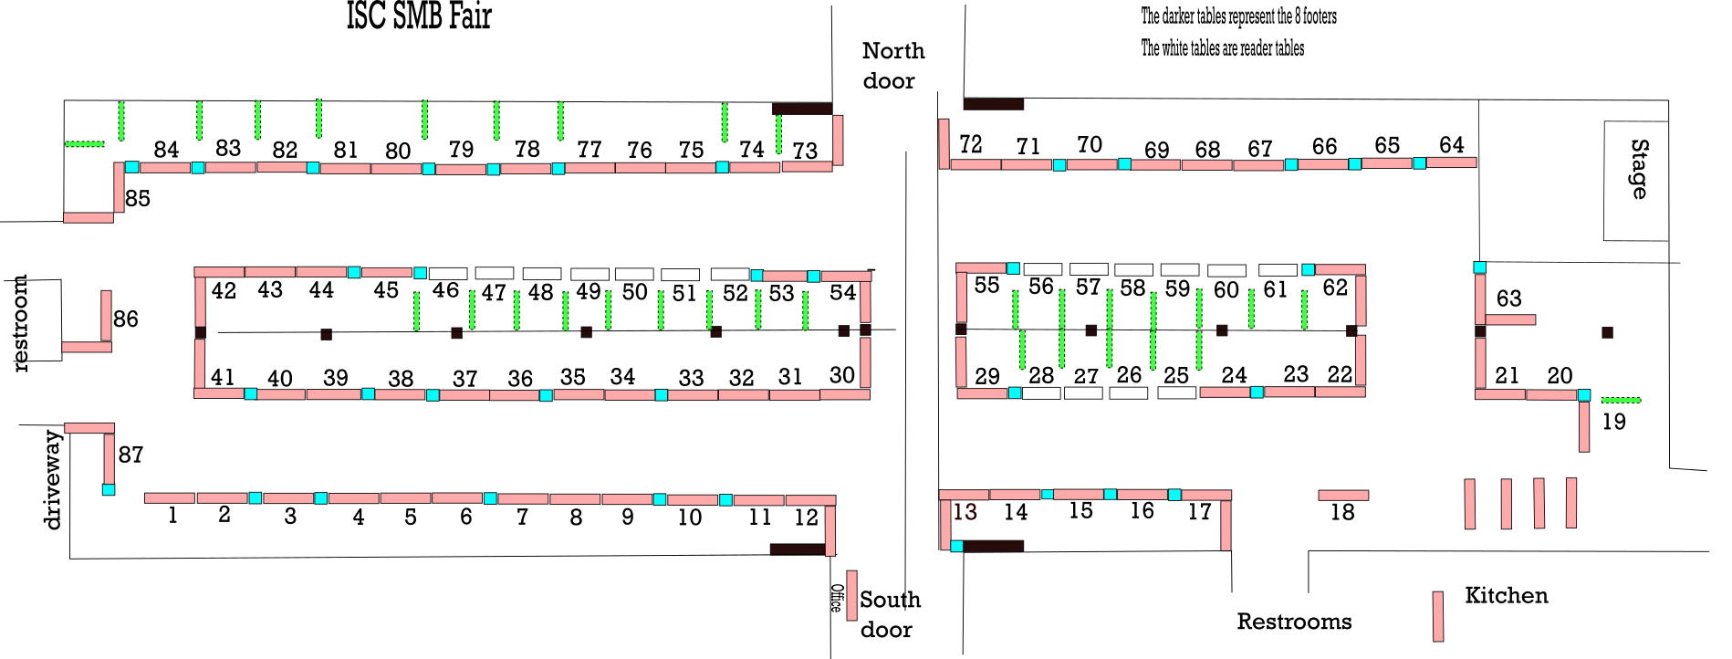

I hereby agree to the terms of this contract listed on TERMS OF THE SHOW CONTRACT AND RULES & REGULATIONS included in mail.

Signature: ______________________________________________ Date: _________________________

Make check payable to Infinite Source Church Received by__________________ Date_______________
Mail to 739 SW Vesper St, Topeka, KS 66606
Approved_________________ Bal. Due_______________

